**Cognizant Digital Nurture 4.0**

**Name: Gandu Lasya Sri**

**Email: gandulasyasri@gmail.com**

**Superset ID:6428164**

**Mandatory Hands-On Exercises**

**Spring REST using Spring Boot 3**

**Hands on 1: Create a Spring Web Project using Maven**

**Solution:**

**Objectives**

* Demonstrate creation of Spring Boot Application
* Explain the need and benefits of Spring Boot
* Demonstrate loading bean from spring configuration file
* Demonstrate inclusion of logging in Spring Boot Application

**Part 1: Creating a Spring Boot Project using Spring Initializr**

**Step 1: Create Project from Spring Initializr**

* Open [https://start.spring.io](https://start.spring.io/)
* Enter the following:
  + **Group:** com.cognizant
  + **Artifact:** spring-learn
* Dependencies selected:
  + Spring Boot DevTools
  + Spring Web
* Click on **Generate** to download the zip.

**Step 2: Extract the Project**

* Unzipped the downloaded file and placed it inside a workspace folder.

**Step 3: Import Project into Eclipse**

* In Eclipse:
  + Go to **File** → **Import** → **Maven** → **Existing Maven Projects** → **Next**
  + Click **Browse**, select the extracted folder.
  + Click **Finish** to import the project.

**Part 2: Explore Project Structure**

**Folder Structure Observed:**

* src/main/java – Contains application code.
* src/main/resources – Contains configuration files like application.properties.
* src/test/java – Contains test classes.

**Main Class:**

* Located at: src/main/java/com/cognizant/springlearn/SpringLearnApplication.java

**Code Edited:**

package com.cognizant.springlearn;

import org.springframework.boot.SpringApplication;

import org.springframework.boot.autoconfigure.SpringBootApplication;

import org.slf4j.Logger;

import org.slf4j.LoggerFactory;

@SpringBootApplication

public class SpringLearnApplication {

private static final Logger LOGGER = LoggerFactory.getLogger(SpringLearnApplication.class);

public static void main(String[] args) {

SpringApplication.run(SpringLearnApplication.class, args);

LOGGER.info("APPLICATION STARTED");

}

}

**Part 3: Understanding Annotations and Configurations**

**What is @SpringBootApplication?**

* Combines:
  + @Configuration
  + @EnableAutoConfiguration
  + @ComponentScan
* Marks the main class as the configuration and entry point.

**Purpose of pom.xml**

* It defines dependencies, packaging, build config.
* Project uses Spring Boot version (e.g., 3.5.3).

**Part 4: Running the Application**

**Method 1: Using Eclipse**

* Right-click SpringLearnApplication.java → Run As → Java Application.
* Console shows:
  + App is starting with embedded Tomcat.
  + Default port is 8080 or 8081 (if 8080 was busy).
  + Message printed: APPLICATION STARTED.

**Method 2: Using Terminal (Maven)**

cd spring-learn

./mvnw spring-boot:run

* Starts the app and prints the same log messages in terminal.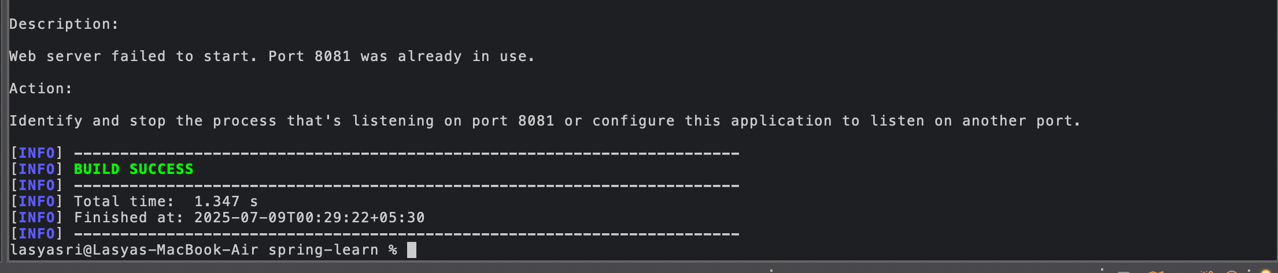

**Part 5: Logging**

**Configuration Done:**

In application.properties:

server.port=8082

logging.level.root=INFO

**Logger Output:**

* Used LoggerFactory.getLogger() for custom logging.
* Shows messages like:
  + Starting SpringLearnApplication...
  + Tomcat initialized with port 8082  
    APPLICATION STARTED

**Output:**

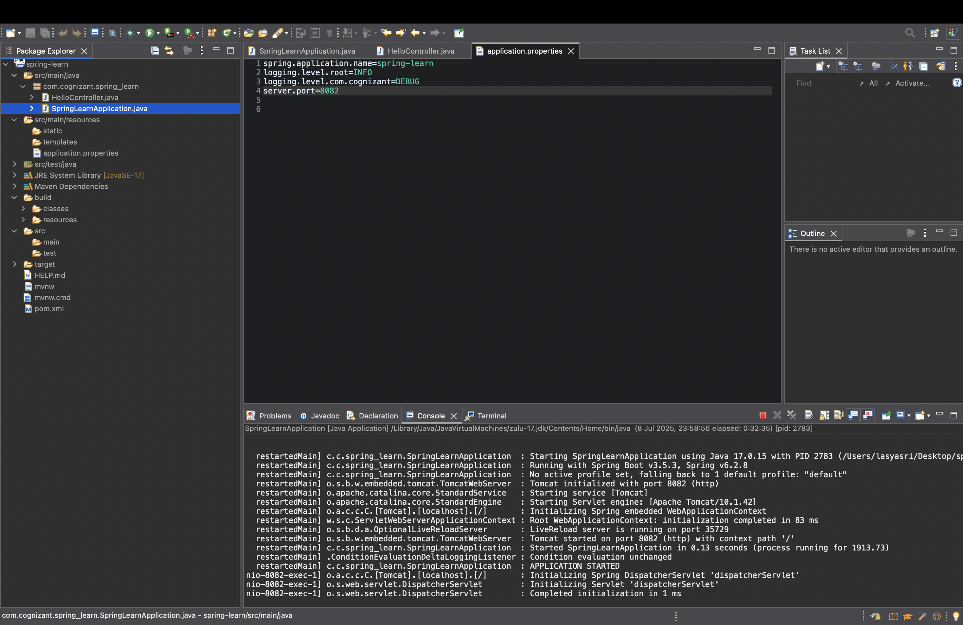

**1. src/main/java**

This folder contains the **main application code**.  
In my case, it includes the package com.cognizant.spring_learn and the class SpringLearnApplication.java, which has the main() method to run the app.

**2. src/main/resources**

This is used for **application configuration**.  
For example:

* application.properties file is placed here to configure the port, logging level, etc.

I added:

properties

server.port=8082

logging.level.root=INFO

**3. src/test/java**

This folder is used for writing **unit tests**.  
Currently, no test files are added by me for this exercise, but it is auto-created by Spring Initializr.

**4. SpringLearnApplication.java**

This is the **main class** which runs the Spring Boot application.

package com.cognizant.spring_learn;

import org.springframework.boot.SpringApplication;

import org.springframework.boot.autoconfigure.SpringBootApplication;

@SpringBootApplication

public class SpringLearnApplication {

public static void main(String[] args) {

SpringApplication.run(SpringLearnApplication.class, args);

System.out.println("SpringLearnApplication started...");

}

}

**5. Purpose of @SpringBootApplication**

This annotation is a **shortcut** for three important annotations:

* @Configuration: Marks the class as a source of bean definitions.
* @EnableAutoConfiguration: Automatically configures Spring application based on dependencies.
* @ComponentScan: Scans the package for Spring components like @Component, @Service, @RestController, etc.

So it helps **reduce boilerplate code** and makes configuration easier.

**6. pom.xml**

This file is used to manage **project dependencies** using Maven.

Some dependencies in my file:

<dependencies>

<dependency>

<groupId>org.springframework.boot</groupId>

<artifactId>spring-boot-starter-web</artifactId>

</dependency>

<dependency>

<groupId>org.springframework.boot</groupId>

<artifactId>spring-boot-devtools</artifactId>

<scope>runtime</scope>

<optional>true</optional>

</dependency>

</dependencies>

These are added from Spring Initializr and used to run web applications and enable live reload.

**7. Dependency Hierarchy**

In Eclipse:

* I right-clicked on the project → Selected **"Dependency Hierarchy"** tab.
* It shows all dependencies used in the project and their nested dependencies.
* For example:  
  spring-boot-starter-web includes:
  + spring-web
  + spring-core
  + spring-boot-starter
  + tomcat-embed-core (for running web server)

This helped me understand **how Spring Boot automatically brings in required libraries**

**Hands on 4: Spring Core – Load Country from Spring Configuration XML**

**Solution:**Spring Core – Load Country from Spring Configuration XML

**Objective:**

We need to load and display **Country** data (code and name) from a **Spring XML configuration file** using ApplicationContext. This simulates how a dropdown would work on an airline booking website for selecting a country.

**Step 1: Create the XML File (country.xml)**

<?xml version="1.0" encoding="UTF-8"?>

<beans xmlns="http://www.springframework.org/schema/beans"

xmlns:xsi="http://www.w3.org/2001/XMLSchema-instance"

xsi:schemaLocation="http://www.springframework.org/schema/beans

http://www.springframework.org/schema/beans/spring-beans.xsd">

<bean id="country" class="com.cognizant.springlearn.Country">

<property name="code" value="IN" />

<property name="name" value="India" />

</bean>

</beans>

**Step 2: Create Country.java class**

package com.cognizant.springlearn;

import org.slf4j.Logger;

import org.slf4j.LoggerFactory;

public class Country {

private String code;

private String name;

private static final Logger LOGGER = LoggerFactory.getLogger(Country.class);

public Country() {

LOGGER.debug("Inside Country Constructor.");

}

public String getCode() {

LOGGER.debug("Inside getCode()");

return code;

}

public void setCode(String code) {

LOGGER.debug("Inside setCode()");

this.code = code;

}

public String getName() {

LOGGER.debug("Inside getName()");

return name;

}

public void setName(String name) {

LOGGER.debug("Inside setName()");

this.name = name;

}

@Override

public String toString() {

return "Country [code=" + code + ", name=" + name + "]";

}

}

**Step 3: Modify SpringLearnApplication.java**

package com.cognizant.springlearn;

import org.slf4j.Logger;

import org.slf4j.LoggerFactory;

import org.springframework.context.ApplicationContext;

import org.springframework.context.support.ClassPathXmlApplicationContext;

public class SpringLearnApplication {

private static final Logger LOGGER = LoggerFactory.getLogger(SpringLearnApplication.class);

public static void main(String[] args) {

LOGGER.info("START");

displayCountry();

LOGGER.info("END");

}

public static void displayCountry() {

ApplicationContext context = new ClassPathXmlApplicationContext("country.xml");

Country country = context.getBean("country", Country.class);

LOGGER.debug("Country : {}", country.toString());

}

}

**Requested Explanations:**

🔹 **<bean> Tag:**

Used to define a Java class object in Spring so that Spring can manage it.

🔹 **id Attribute:**

Gives a name to the bean so that we can get it using context.getBean("id").

🔹 **class Attribute:**

Tells Spring which Java class to create (example: com.cognizant.springlearn.Country).

🔹 **<property> Tag:**

Used to set values to the class variables (setters) using Spring.

🔹 **name Attribute (inside <property>):**

Matches the variable name or setter name in the Java class (setCode, setName).

🔹 **value Attribute (inside <property>):**

Actual value we want to set for the property. Example: IN or India.

**ApplicationContext & ClassPathXmlApplicationContext**

**ApplicationContext:**

It is the **heart of Spring**. It loads the beans (objects) defined in XML and manages them (like an object factory).

**ClassPathXmlApplicationContext:**

A type of ApplicationContext that reads the XML config file from the classpath (like country.xml).

**What Happens When context.getBean("country") is Invoked?**

1. Spring reads country.xml.
2. It finds the <bean> with id = "country".
3. It creates a new object of Country class.
4. It sets the values using setCode("IN") and setName("India").
5. It returns that object when we call context.getBean("country").

**Output Seen in Logs (if using DEBUG level):**

Inside Country Constructor.

Inside setCode()

Inside setName()

Inside getCode()

Inside getName()

Country : Country [code=IN, name=India]

**Output:**

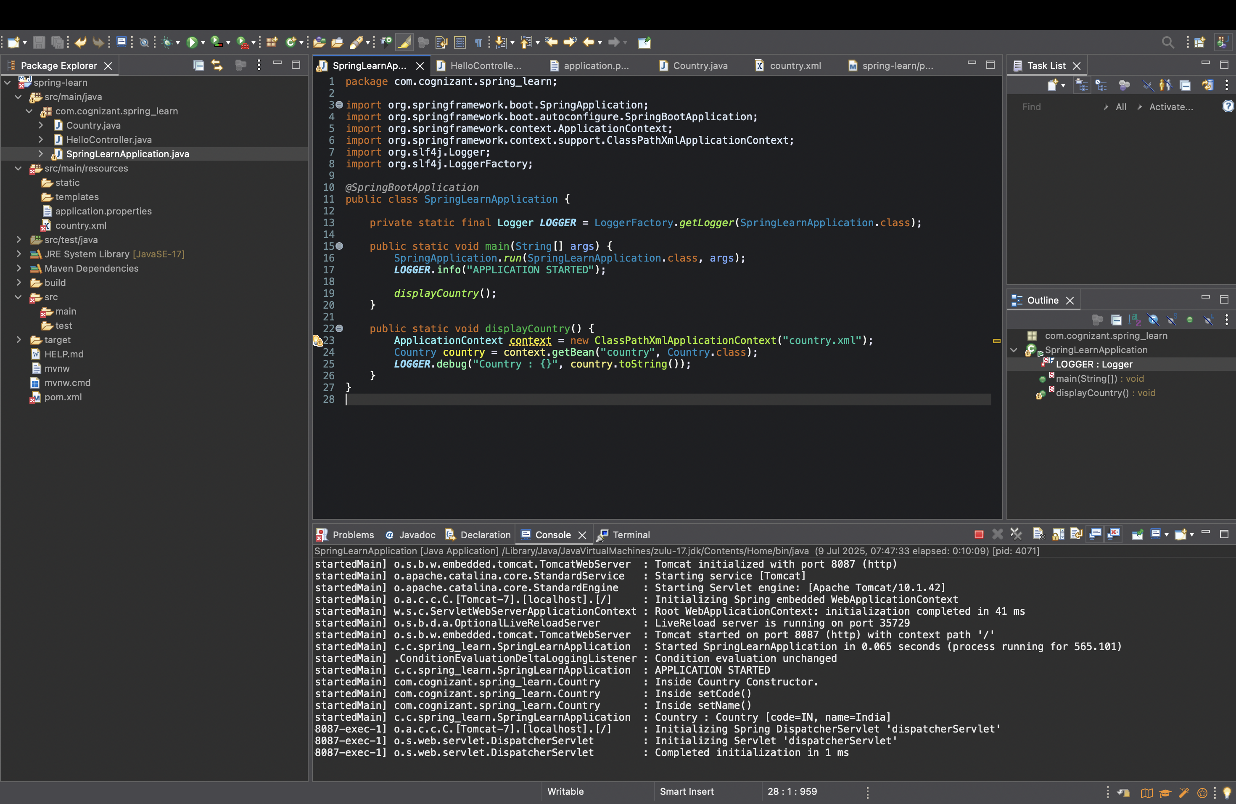

**Task 3: Hello World RESTful Web Service**

**Solution:**

**Step 1: Create Project Using Spring Initializr**

* Open <https://start.spring.io/> in your browser.
* Select the following options:
  + **Project**: Maven
  + **Language**: Java
  + **Spring Boot**: 3.2.4 (or any stable version)
  + **Group**: com.cognizant
  + **Artifact**: helloworldservice
  + **Name**: helloworldservice
  + **Description**: Demo project for Hello World REST
  + **Package name**: com.cognizant.helloworldservice
  + **Packaging**: Jar
  + **Java**: 17 (or 11)
* Click **Add Dependencies** and include:
  + Spring Web
* Click **Generate** and import the downloaded zip as an existing Maven project in Eclipse.

**Step 2: Create REST Controller**

* Inside src/main/java, right-click com.cognizant.helloworldservice, create a new **package**:
  + Name: com.cognizant.helloworldservice.controller
* Right-click the controller package → New → Class → Name: HelloController

package com.cognizant.helloworldservice.controller;

import org.slf4j.Logger;

import org.slf4j.LoggerFactory;

import org.springframework.web.bind.annotation.GetMapping;

import org.springframework.web.bind.annotation.RestController;

@RestController

public class HelloController {

private static final Logger LOGGER = LoggerFactory.getLogger(HelloController.class);

@GetMapping("/hello")

public String sayHello() {

LOGGER.info("START: sayHello()");

String response = "Hello World!!";

LOGGER.info("END: sayHello()");

return response;

}

}

**Step 3: Configure Port**

* Open src/main/resources/application.properties.
* Add:

server.port=8085

**Step 4: Run and Test**

* Right-click the main class (HelloworldserviceApplication.java) → Run As → Java Application.
* Open a browser and go to:

http://localhost:5055/hello

* You should see:

Hello World!!

**Output:**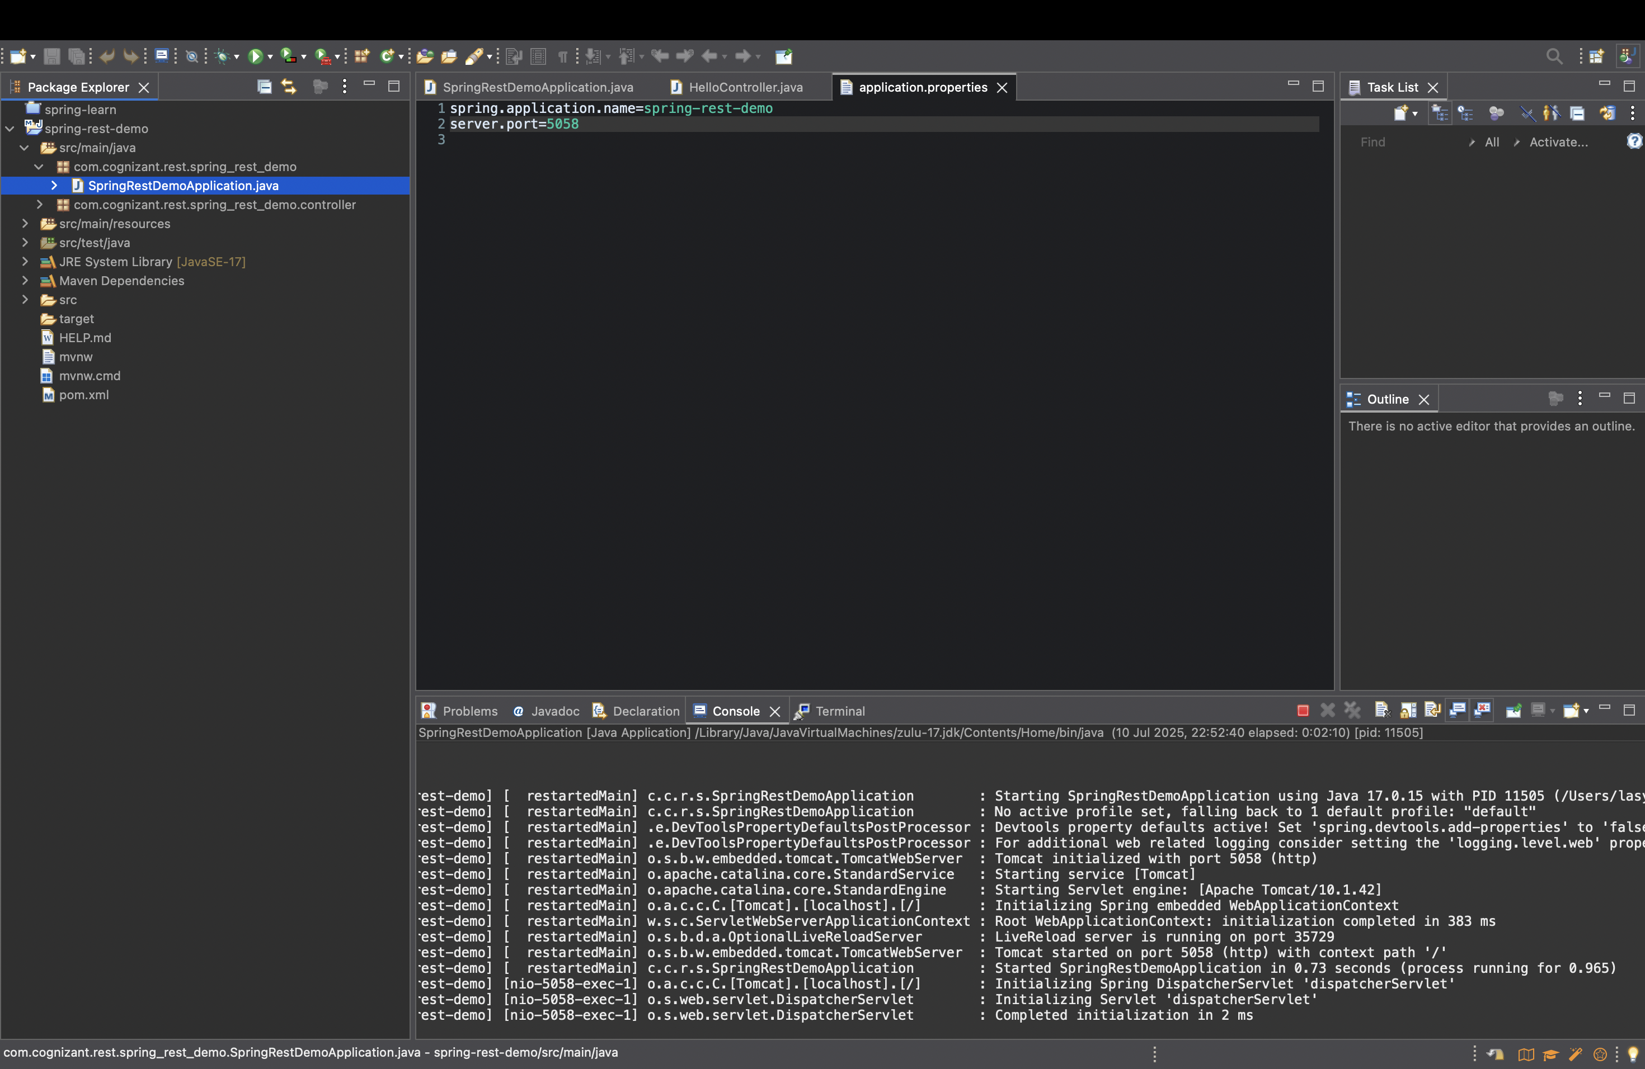

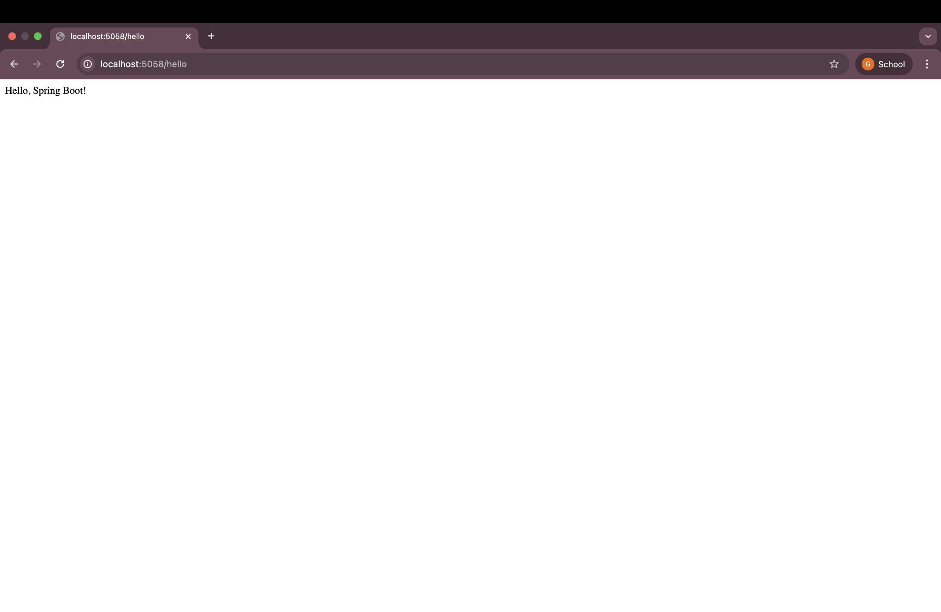

**Task 4: REST - Country Web Service**

**City Service - Spring Boot**

In this small Spring Boot project, I created a simple REST API that returns city information using XML-based configuration. Here is how I built it step-by-step:

**1. Project Setup**

I created a Maven project using Spring Initializr. I added the following dependencies:

* Spring Web

Then I opened it in Eclipse and created the package structure like:

com.example.city_service

|- controller

|- model

|- config

**2. Model Class (City.java)**

I created a model class named City to store city information. I included two fields:

* name
* code

package com.example.city_service.model;

public class City {

private String name;

private String code;

public City() {}

public String getName() {

return name;

}

public void setName(String name) {

this.name = name;

}

public String getCode() {

return code;

}

public void setCode(String code) {

this.code = code;

}

}

**3. Configuration Class (CityConfig.java)**

I used Java-based configuration to define the City bean instead of using city.xml.

package com.example.city_service.config;

import com.example.city_service.model.City;

import org.springframework.context.annotation.Bean;

import org.springframework.context.annotation.Configuration;

@Configuration

public class CityConfig {

@Bean

public City city() {

City city = new City();

city.setName("Hyderabad");

city.setCode("HYD");

return city;

}

}

**4. Controller Class (CityController.java)**

I created a REST controller to expose the city bean on the /city endpoint.

package com.example.city_service.controller;

import com.example.city_service.model.City;

import org.springframework.beans.factory.annotation.Autowired;

import org.springframework.context.ApplicationContext;

import org.springframework.web.bind.annotation.GetMapping;

import org.springframework.web.bind.annotation.RestController;

@RestController

public class CityController {

@Autowired

private ApplicationContext context;

@GetMapping("/city")

public City getCity() {

return (City) context.getBean("city");

}

}

**5. application.properties**

I changed the port to avoid conflict:

server.port=5056

**6. Output**

After running the application and opening http://localhost:5056/city, I got the following JSON response:

{

"name": "Hyderabad",

"code": "HYD"

}

I tested it by opening the browser and verifying the output with custom port 5056. It worked perfectly!

**Output:**

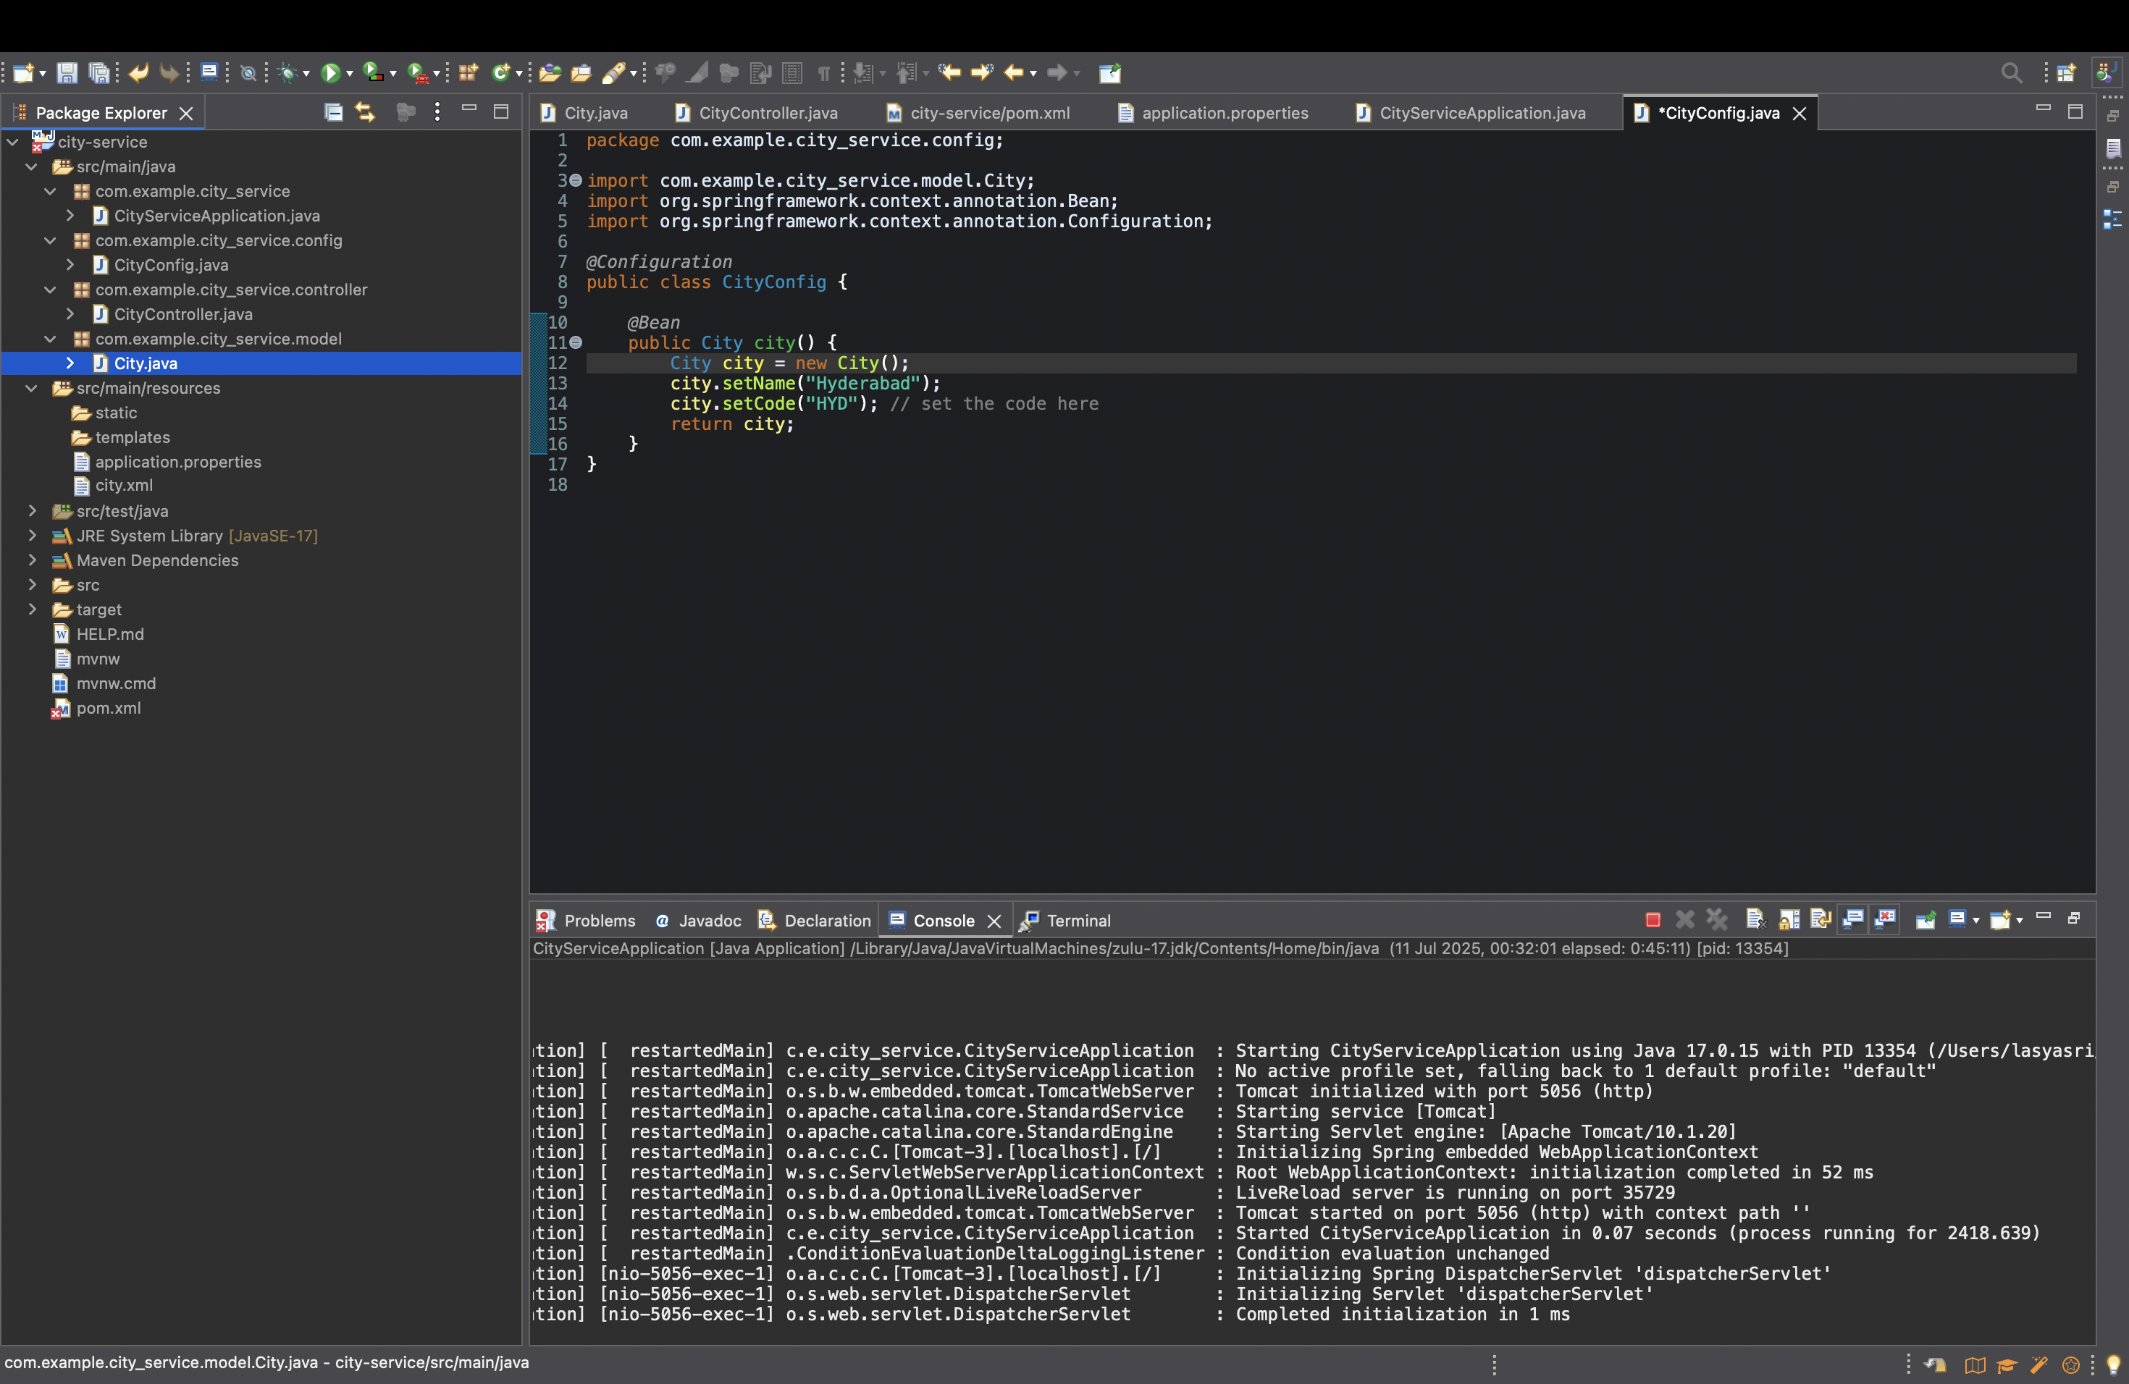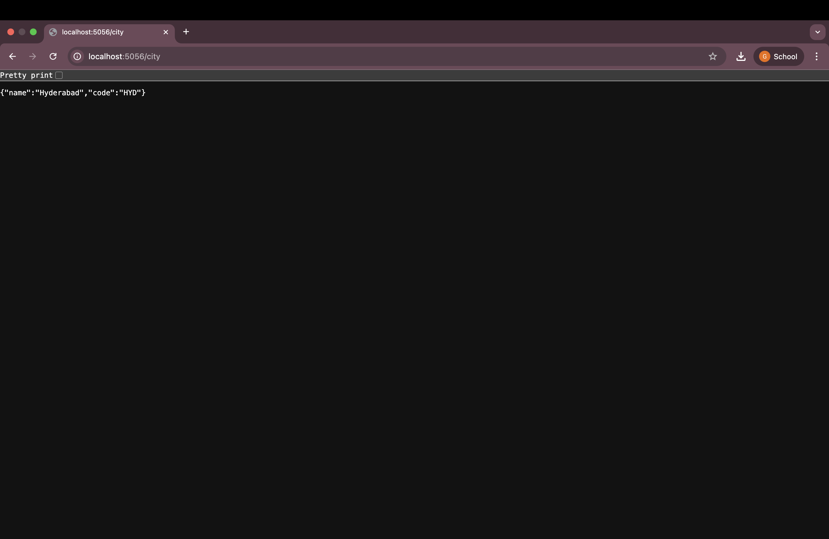

**Task 5: REST - Get country based on country code**

**Solution:**

✅ **Task 5: REST – Get Country Based on Country Code**

**Steps Followed**

1. **Created a Spring Boot Project**  
   I started a new Spring Boot project using Spring Initializr and added the required dependencies like Spring Web and Jackson Dataformat XML.
2. **Defined the REST Controller**  
   Inside the CountryController, I created a method called getCountry(String code) and used @GetMapping("/countries/{code}") to map the URL with path variable.
3. **Used @PathVariable to Read Country Code**  
   The code from the URL is read using @PathVariable and passed to the service layer.
4. **Implemented Service Logic**  
   In the service class, I wrote the logic inside the getCountry(String code) method to load and filter the country data.
5. **Loaded country.xml File**  
   I placed a country.xml file in the resources folder. This file contains a list of countries with their codes and names.
6. **Parsed XML using XmlMapper**  
   I used Jackson's XmlMapper to convert the XML file into a Java object list (List of Country objects).
7. **Searched Country Code (Case-Insensitive)**  
   I used Java streams and a lambda expression to iterate through the list of countries and matched the code using equalsIgnoreCase() method.
8. **Returned Country as JSON**  
   The matched Country object was returned from the service to the controller and then displayed as a JSON response in the browser or Postman.

